Lesson Plan Title

Subject:  Related Subjects: | Grade Level(s): Grade 8,  Length of Lesson: | Type: Inquiry / Design / Project  Keywords:Superstructure, Substructure, Compression, Tension, Shear, Torsion, Bending, Abutment, Arch, Critical load, Live load, Strut, Suspension, Torque, Strut, Chord, Vertical

Lesson Overview
Use this section to describe at a high level what the lesson is. Should be no more than 3-4 lines.

Lesson Focus
What is the central question or phenomenon being investigated? What problem are they trying to solve?

Lesson Objective(s) | Use math and science to understand engineering concepts and to build skills.  Design and construct a model bridge that will carry a maximum load while using as little wood as possible, stressing neatness, craftsmanship, and creativity.

Lesson Timing

5 minutes | Introduce the Lesson
30 minutes | ...

Materials | - Activity 1:  - 1 – 3 x 5 index card  - 1 – Ruler  - 6 – Hex nuts  - 2 – Blocks  - Activity 2:  - 2 – 3 x 5 index cards 1 – Ruler  - 15 – Hex nuts 1 – Pair of scissors  - 2 - Blocks Masking Tape  - Activity 3:  - 2 – 3 x 5 index cards  - 35 – Hex nuts  - 1 – Ruler  - 1 Pair of scissors  - 2 - Blocks
Instructor Prep | - Step 1
Related Resources | - List related lessons/ppts etc available from USC or outside, trusted orgs

Lesson Plan

Introduction
Stress and Strain

When a force is applied to an object with either a pushing or pulling motion, the object is being stressed. For example, if a spring is pulled apart it changes shape. This change of shape is called strain.
Force Lines
Elasticity

When a load is placed upon an object, lines of force occur. These lines of force are carried through all parts of the object towards the ground.
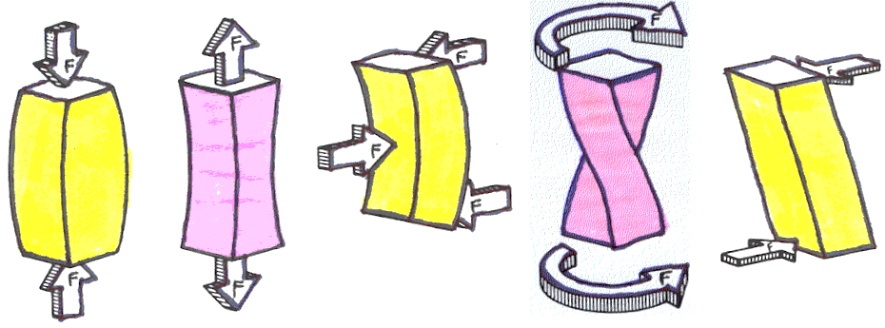
Just like a rubber band returns to its original shape, most materials do the same thing. When a material is stressed and it returns to its original shape it is showing the property of elasticity.

Compression | Tension | Bending | Torsion | Shearing

Procedure
Activity 1:
- Place two blocks 4” apart.

- Create a bridge by placing the 3 x 5 card over space between blocks.

- Add hex nuts until card collapses into space between blocks.

- Document number of hex nuts below.

Distance Apart – Blocks | 4”
# of Hex nuts

- Describe what happened below. Describe load? What forces come into play? What is the pushing force on the 3x5 card bridge?

Activity 2:
- Take one 3 x 5 card and cut out four ½” x 3” strips.

- Line up 4 strips length-wise and fold the corners up from right to left for two creating right triangles and fold the corners up from left to right for the remaining two creating right triangles.

- Create an arch by taping the unfolded end of a right-folded strip to the unfolded end of a left-folded strip.

- Repeat and create a second arch.

- Unfold corners of both arches so that the corners stick straight up when the strip is laying on the table

- Attach both arches to the edges of a 3 x 5 card by taping the folder corners onto the surface of the card. This will make the arches stand up.

- Create a bridge by placing the structure over the space between the blocks 4” apart.

- Add hex nuts until card collapses into space between blocks.

- How hex nuts could the structure support?
What is the difference between what happened in Activity 1 and what happened here?

Activity 3:
- Take one 3 x 5 card and cut out four ½” x 3” strips.

- Line up 2 strips length-wise and fold the corners up from right to left creating right triangles (see step 2 in Activity 2).

- Using the structure from Activity 2, attach and tape folded corner strips to top of arches.

- Using the 2 other ½” x 3” strips, attach and tape to the top of arches parallel to the strips tapes in the above step.

- From remaining index card, cut out four ½” x 2.5” strips. Use these four strips as the vertical supports at the ends of the structure.

- Create a bridge by placing the structure over the space between the blocks 4” apart.

- Add hex nuts until card collapses into space between blocks.

- How hex nuts could this structure support?
What is the difference between what happened in Activity 1, in Activity 2, and what happened here?

- With the second 3 x 5 index card, cut out two ½” x 5” strips.

- Use these two strips as the top cross bars. Fold and tape strips to top edges of structure.

Wrap-up
- How hex nuts could this structure with the top cross bars support?

- What is the difference in the load in this structure? What is the difference in the types of stress on this structure? What forces come into play with this structure? In the diagram above, indicate which direction the forces flow and the types of stress when the hex nuts are placed in the center of the structure (on the middle of the 3x5 index card).

Lesson Background for Teachers

Suggested Real-World STEM Connections
- List possible related Role Models in STEM (with details and links to more reading). Give suggestions for examples of scientists/engineers who are from underrepresented groups in STEM in related careers.
- List related real-world engineering problems and examples

Lesson Variations and Options
Include descriptions of alternative methods or ways to present things.

Explanation
Describe the background concepts and explanations behind the lesson. This can be more in depth than a teacher/instructor would actually share with students.

Key Concepts and Vocabulary
- Word 1: Grade Appropriate Definition
- Word 2: Grade Appropriate Definition

Safety Notes
- Safety instruction

